**Receive Change Request**

**Module Description**

In this module the Client has responded to the Release 1 UAT with a number of change requests. This is your opportunity to review the change requests, ask any relevant questions and begin planning how to address them.

**Scenario**

The Development Team Manager notifies you that the new requirements have been identified and are now documented as Change Requests by the Client. The Client would like details on the effort required to determine if the change should wait until a future phase or, be completed in the current phase. A follow-up email has been sent about this.

You also receive the defect list from the Release 1 UAT for review. You will work with your Team Lead to determine who on the team will work on the Change Requests and who will work on the defects.

You will read through the email and the Change Requests to get background information on what the change is about, what areas are affected and how it impacts the code you and other teams have written.

Your Team Lead should plan to hold a status meeting with you and your teammates to discuss the Change Request, the defects identified and to decide on the next steps.

**ADM Activity Context Diagram**

**High Level Context Diagram**

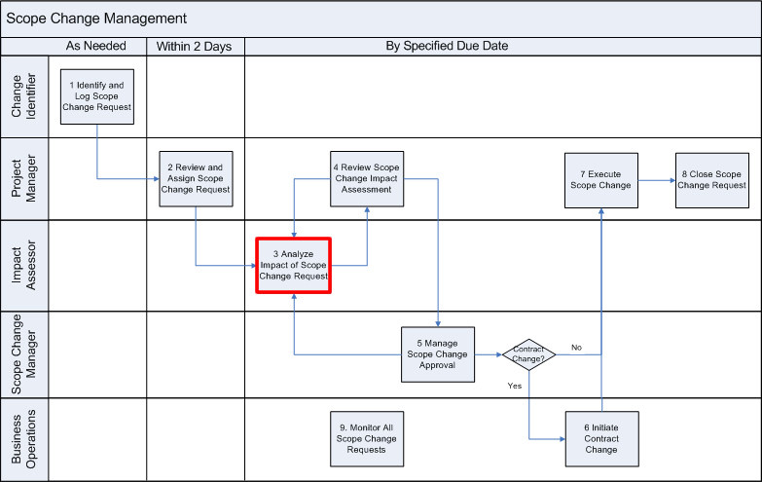

**Low Level Context Diagram**

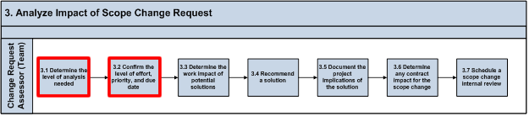

**Roles**

|  |  |  |  |
| --- | --- | --- | --- |
| **Role** | **ADM Task** | **ADM Responsibility** | **Description** |
| Team Lead | N/A | Manager – Management Oversight Team Lead Team (All) Primary Performer | Reviews the Change Requests and the Defect List and starts to consider how to divide the activities for Release 2. |
| Team (All) | N/A | Manager – Management Oversight Team Lead Team (All) Primary Performer | Review the Change Requests and the Defect List to understand what is in scope (the features required) for Release 2. |

**Participant Instructions**

**Team All:**

1. Review the Change Request email in the News section of the web site's home page, and then go to the Activity 2 Inputs page after this one to review the Change Request Template and Defect List.

**Team Lead:**

2. Give all your team members 30 minutes to read the Change Request email, Change Request work product and the Defect List. Prepare for a status meeting to discuss the Change Requests and the Defect List.

**Team All:**

3. Review the Change Request to ensure you have enough information to proceed. If not, submit a request for additional information to the Manager.

**Note**: Do NOT update the CR tracker at this point. Using the query log only, ensure you ask questions and check your understanding of the new request.

4. Review the Defect List to ensure you have enough information to proceed. If not, submit a request for additional information to the Manager.

5. Gather the Analysis and Design Documents above from Release 1 to prepare to determine the initial impressions on the impact of each Change Request.

6. Use your team’s Query Log, to create a version for Release 2. Save your form as *Query Log_FERS_R2_<Team Name>*.*xlsx*, and store it where directed by the Project Management.

7. Prepare a list of questions about the Change Request and items in the Defect List and add them to the Release 2 Query Log.

**Hints and Tips**

The Team Lead should think about to deal with the Change Request and the Defect List. You may want to consider having the team work in parallel (some analyze how to correct the defects, some work on the Change Request review and analysis).